Tomcat Installation on Ubuntu Server ***tutorial***



***Jorge Arcoya López 2ºDAW Bil***

Index

***Introduction 3***

***Installation and Configuration of Tomcat 3***

***Tomcat Check 12***

***Bibliografía 13***

Introduction

The Apache Tomcat server is a reference implementation of the Java Servlet and JavaServer Pages (JSP) technologies, widely used in the development and deployment of Java-based Web applications. Its popularity is due to its ability to efficiently handle high-load environments, its scalability, and its compatibility with different servers and operating systems.

The purpose of this paper is to detail the process of installing and configuring Apache Tomcat on an Ubuntu server. Ubuntu Server is a Linux distribution that is widely used in production environments due to its stability and ease of use, making it an ideal platform for implementing web servers such as Tomcat.

This document describes the steps required to install Tomcat and the basic configurations of Tomcat.

Installation and Configuration of Tomcat

To be able to install Tomcat you must first install the jdk, to install it we will first install aptitude, which is a version finder, with the command “sudo apt-get install aptitude”, the image 1 shows how to set the command.

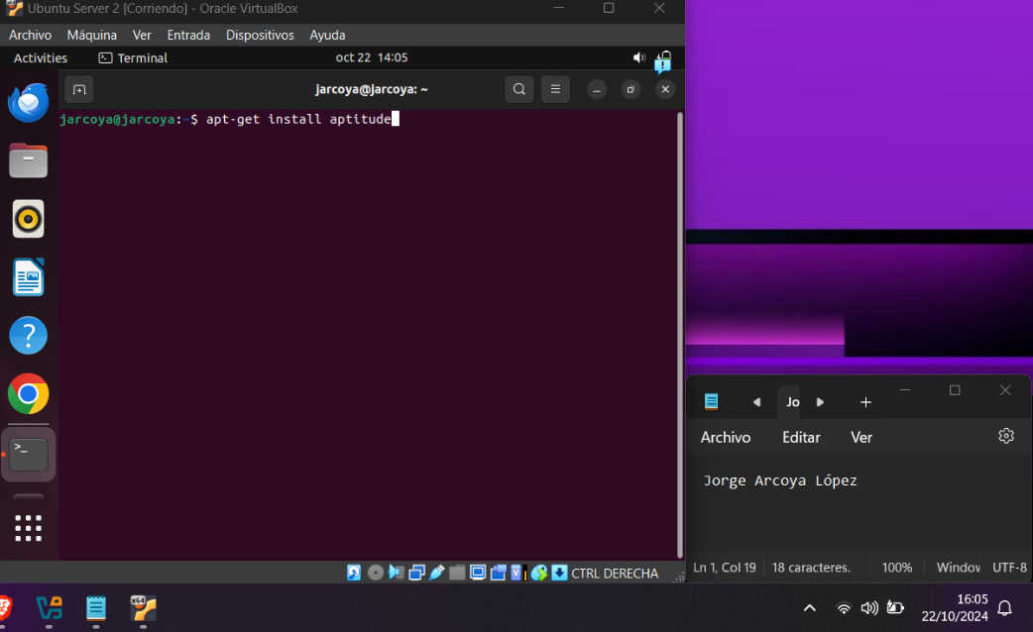

Picture 1 Install Aptitude

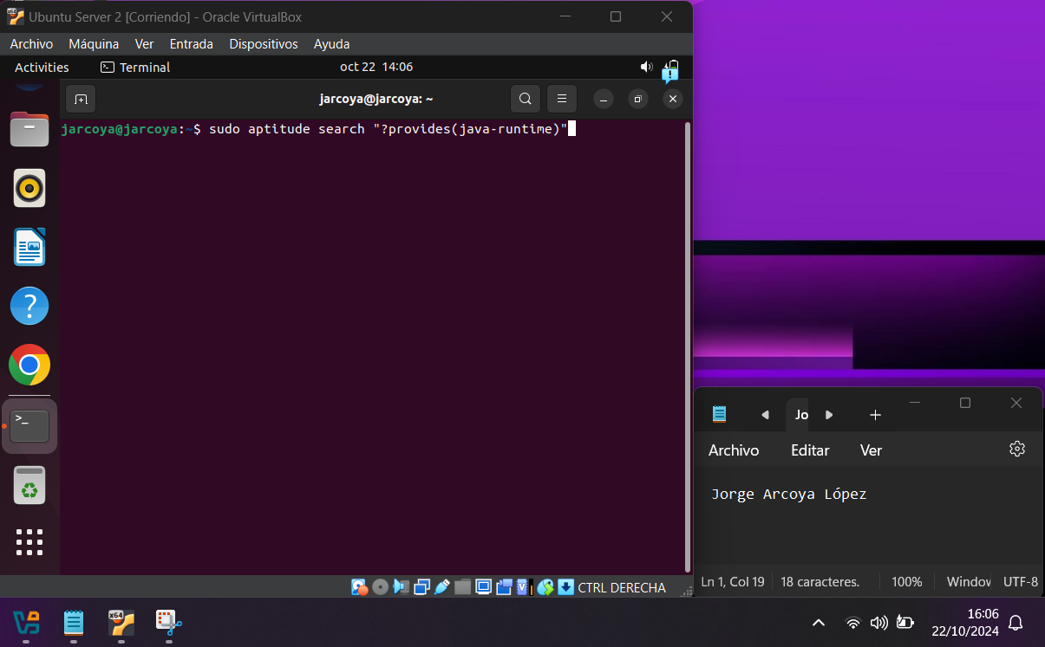When it is installed you have to use the aptitude command ‘sudo aptitude search “?provides(java-runtime)”’ to search for the version of the jdk to install, image 2 shows how to do it.

Picture 2 Search jdk

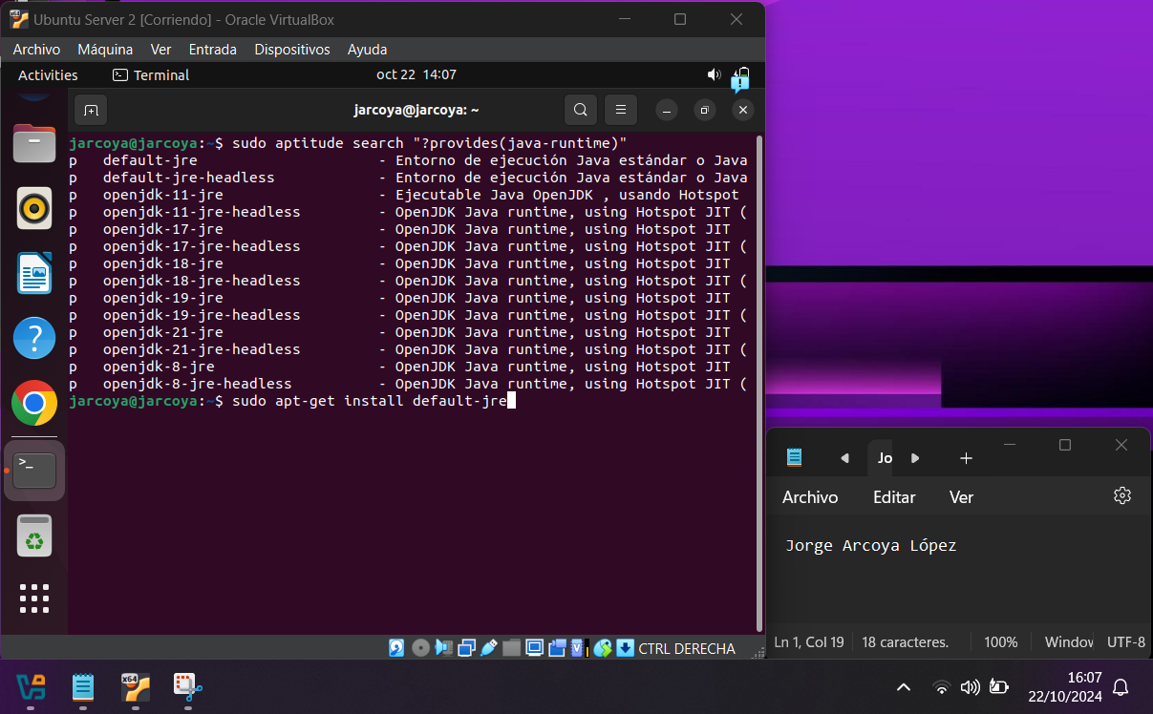Once searched, install the first version that appears using the command “sudo apt-get install default-jre”, image 3 shows how to do this step.

Picture 3 Install jdk

The next thing you can do is to check the version of jdk you have installed using the command “sudo java -version”, image 4 shows how you can do this.

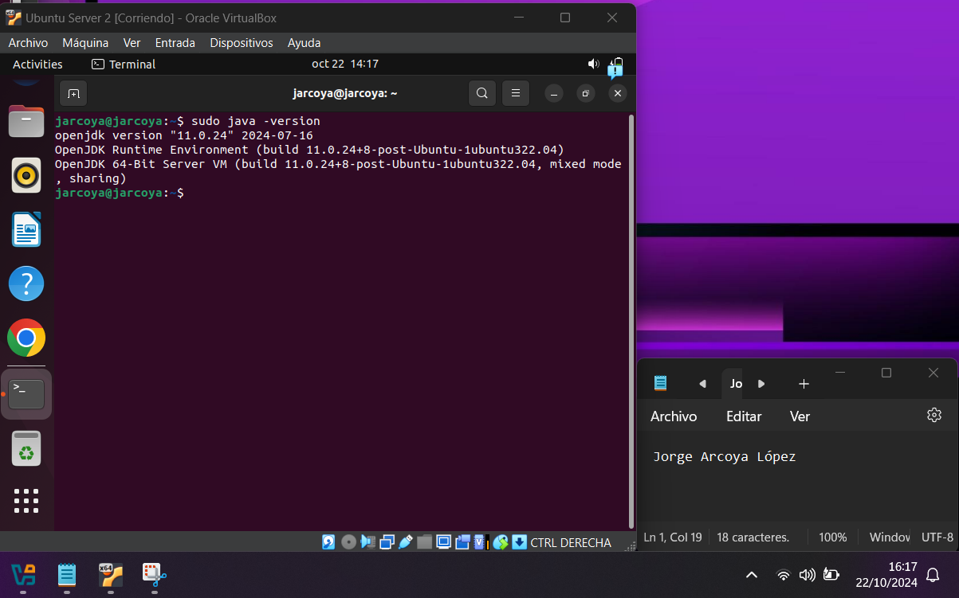

Picture 4 JDK Version

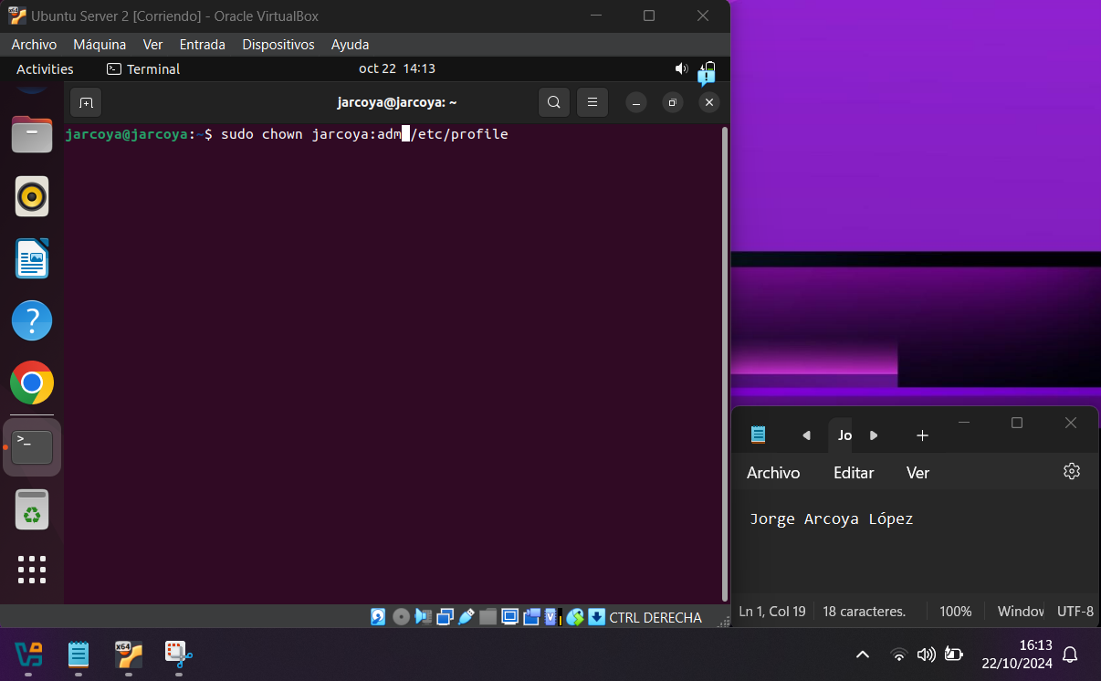After that we have to change the owner of a file that we are going to modify in the next step because with the current user we don't have permission on that user, for that we have to put the command “sudo chown Username:adm /etc/profile” in my case “sudo chown jarcoya:adm /etc/profile”, the image 5 shows how to change the permissions.

Picture 5 Change owner

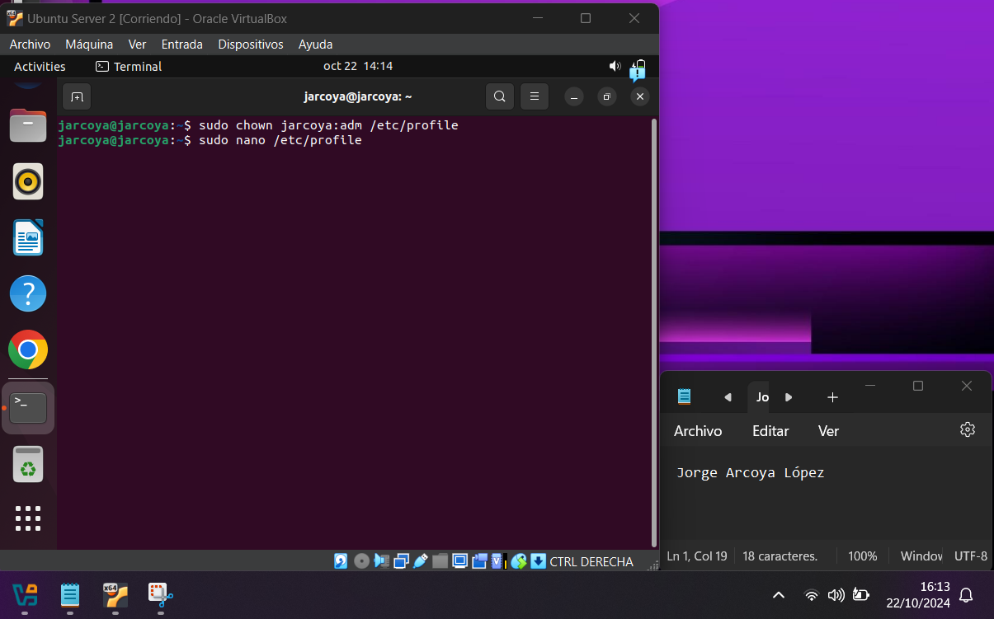Then you have to open a file to create an environment variable to indicate where it has been installed, and add to the PATH variable the directory where the binary files are located so that they can be invoked from anywhere, to open it you have to put the command “sudo nano /etc/profile”, image 6 shows how you have to do it.

Picture Open /etc/profile

Once inside the file, add the following lines to the end of the file:

Picture 6 Open /etc/profile

“ JAVA_HOME=/usr/lib/jvm/java-8-openjdk-amd64/jre/

PATH=$PATH:$JAVA_HOME/bin

export PATH JAVA_HOME ”.

Image 7 shows how to do it

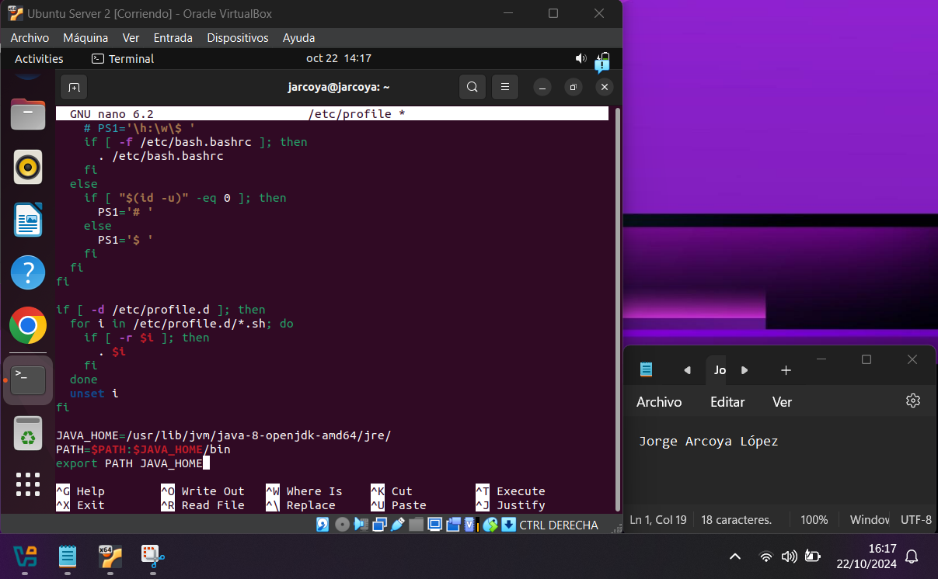

Picture 7 Insert on the end of file

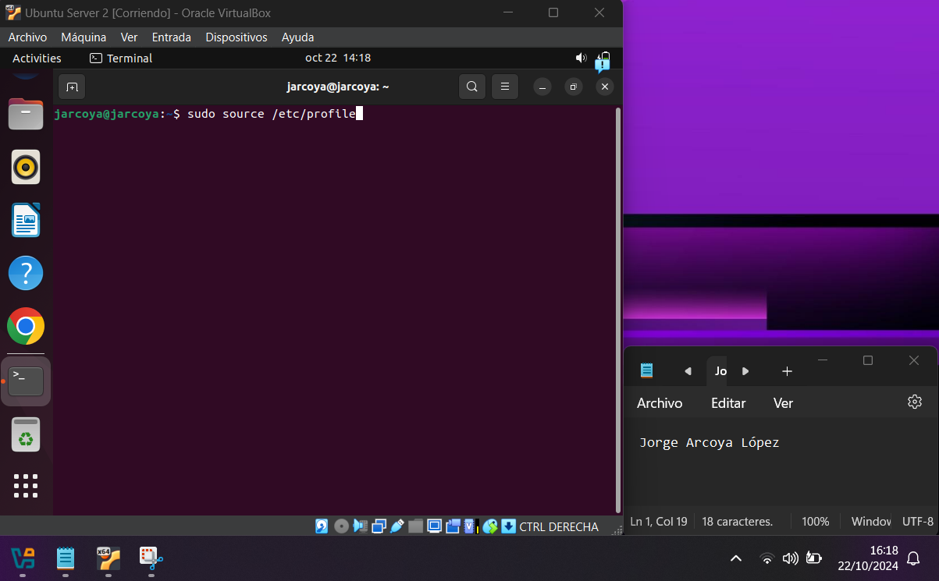The next step is to update the environment variables using the command “source /etc/profile”, picture 8 show how to do it.

Picture 8 Update the environment variables

When executing this command you have to check that the environment variables have been exported correctly, for this you have to use the command ‘echo $JAVA_HOME’, the aimagen 9 shows you how to do it.

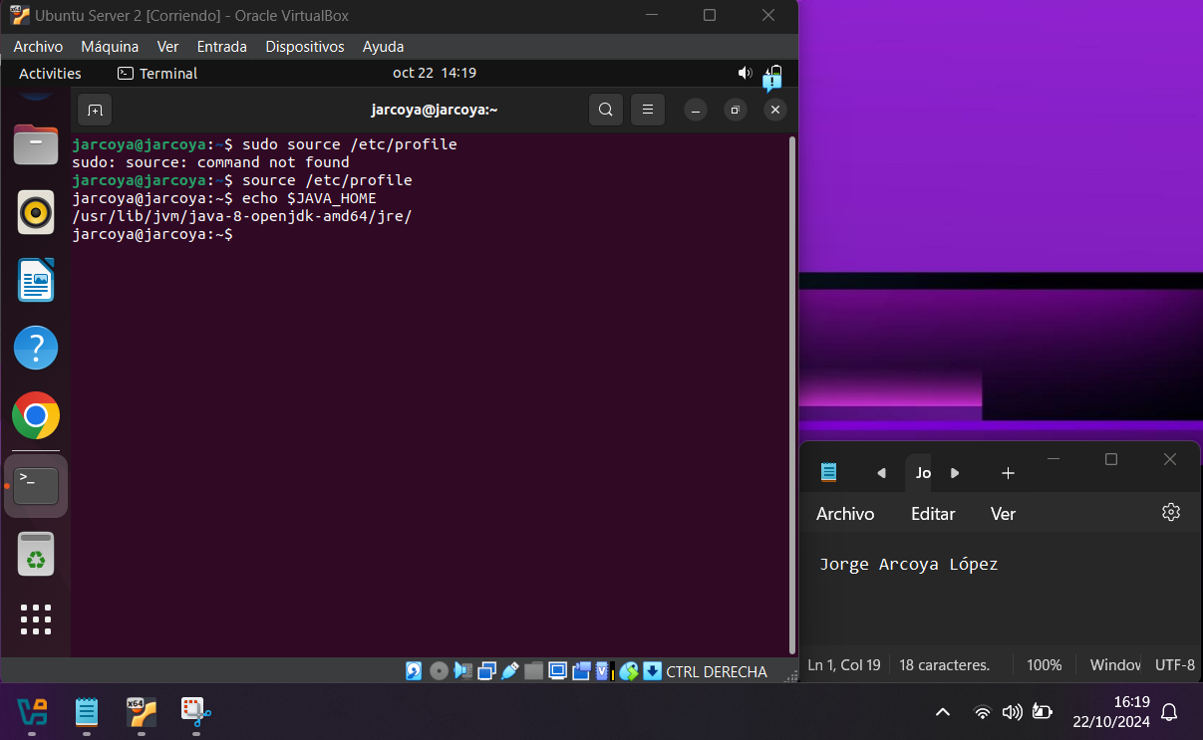

Picture 9 Check environment variables

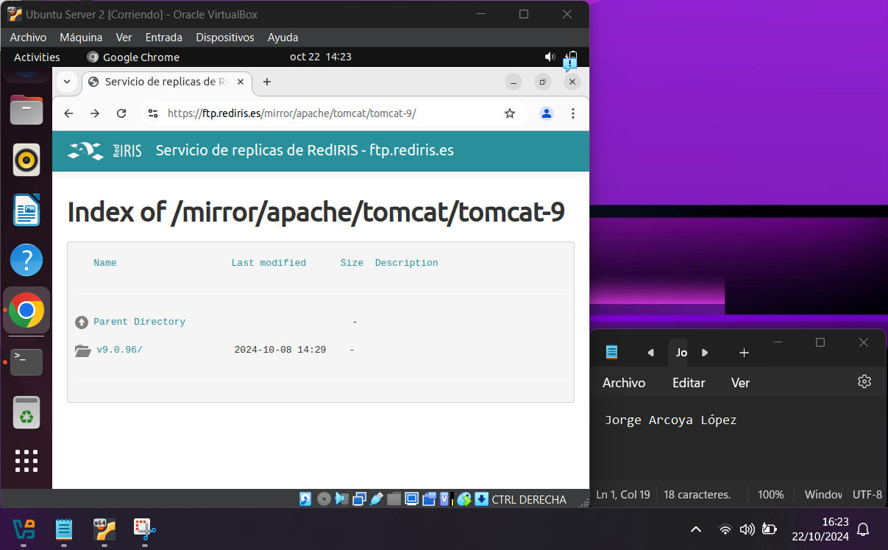Once here, open a browser and go to the following url <https://ftp.rediris.es/mirror/apache/tomcat/tomcat-9/> and a page like the one shown in image 10 should appear.

Picture 10 Download of Tomcat Part1

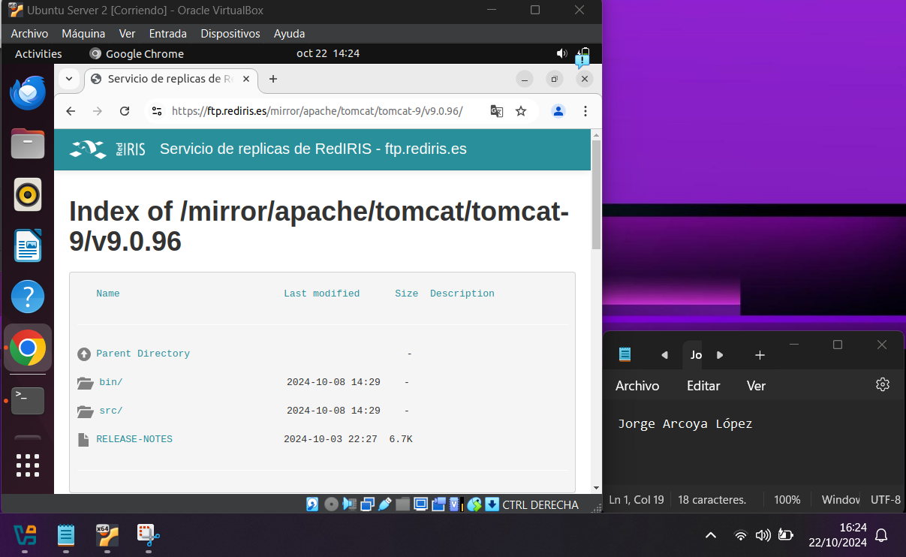After that in this page you have to enter in the section that says v9.0.96/ or the section with the version that appears, when entering should appear a window like the one that shows the image 11.

Picture 11 Download of Tomcat Part 2

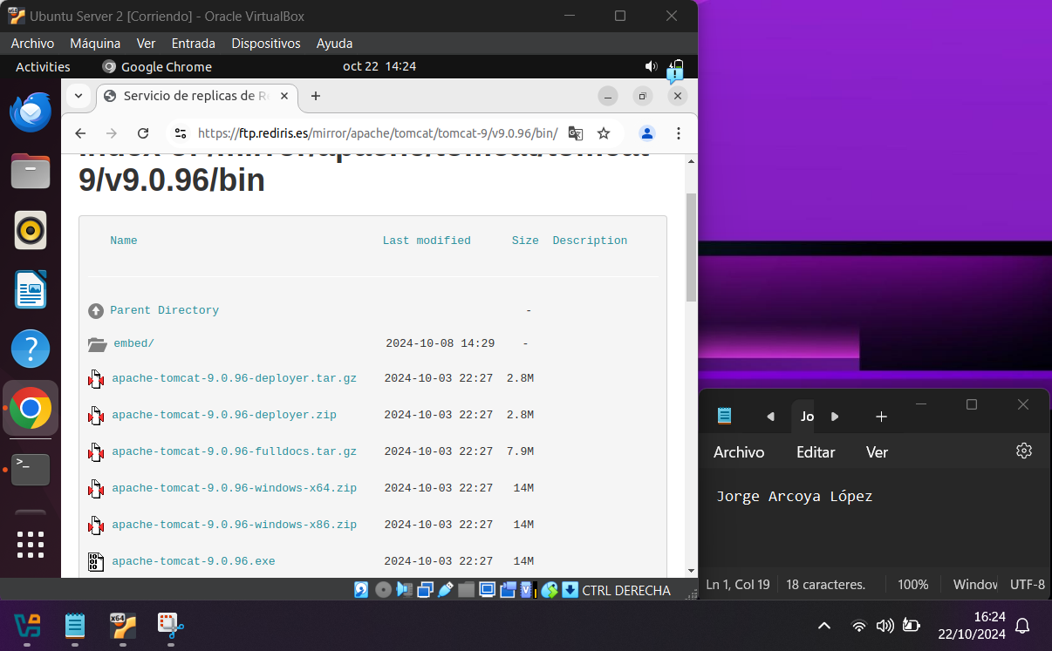On this page you have to enter another section, in this case the bin/ section, image 12 shows what should appear.

Picture 12 Download of Tomcat Part 3

In the list that appears, look for apache-tomcat-9.0.56.tar.gz, or the latest version that appears, and copy the link, and then go back to the terminal and issue the command "sudo wget https://ftp.rediris.es/mirror/apache/tomcat/tomcat-9/v9.0.96/bin/apache-tomcat-9.0.96.tar.gz", replacing it with the copied link, Figure 13 shows how to do this.

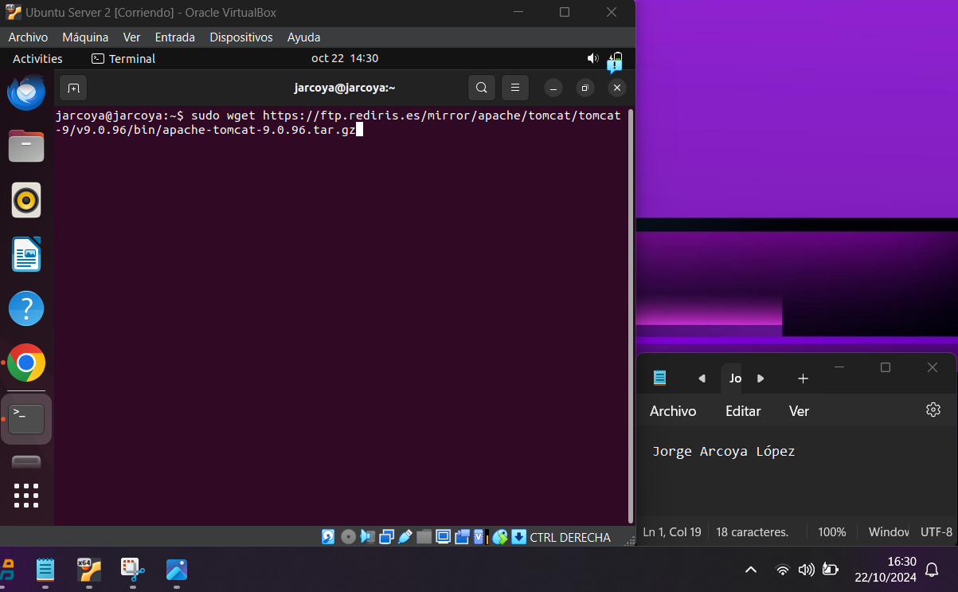

Picture 13 Install Tomcat in the terminal

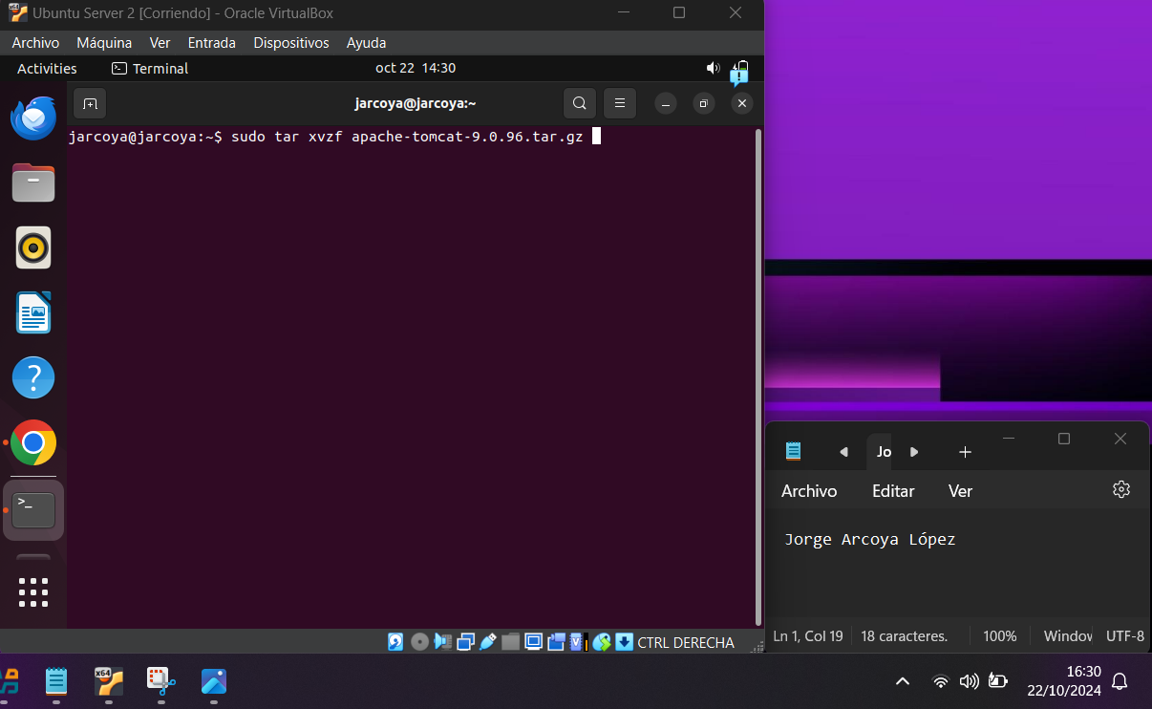After installing it you have to decompress what has been installed. To do this you have to use the command "tar xvzf apache-tomcat-9.0.56.tar.gz" or the version that has been installed. Image 14 shows how you have to decompress it.

Picture 14 Decompress the file

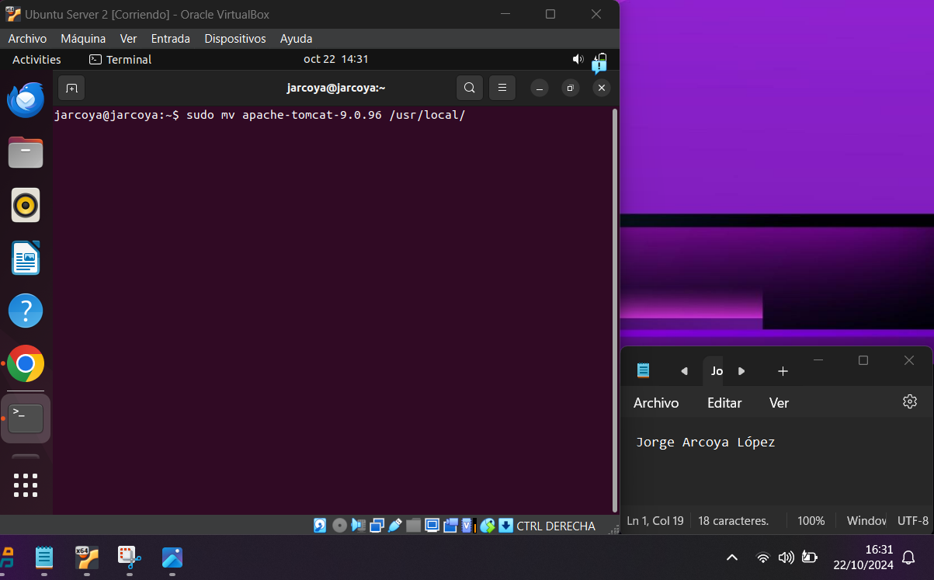Once unzipped, it must be moved to the destination folder where Tomcat ill be saved. To do this, use the command “sudo mv apache-tomcat-9.0.56 /usr/local/” changing the file to the one in which it was installed and unzipped. Image 15 shows how to move the file.

Picture 15 Move the file

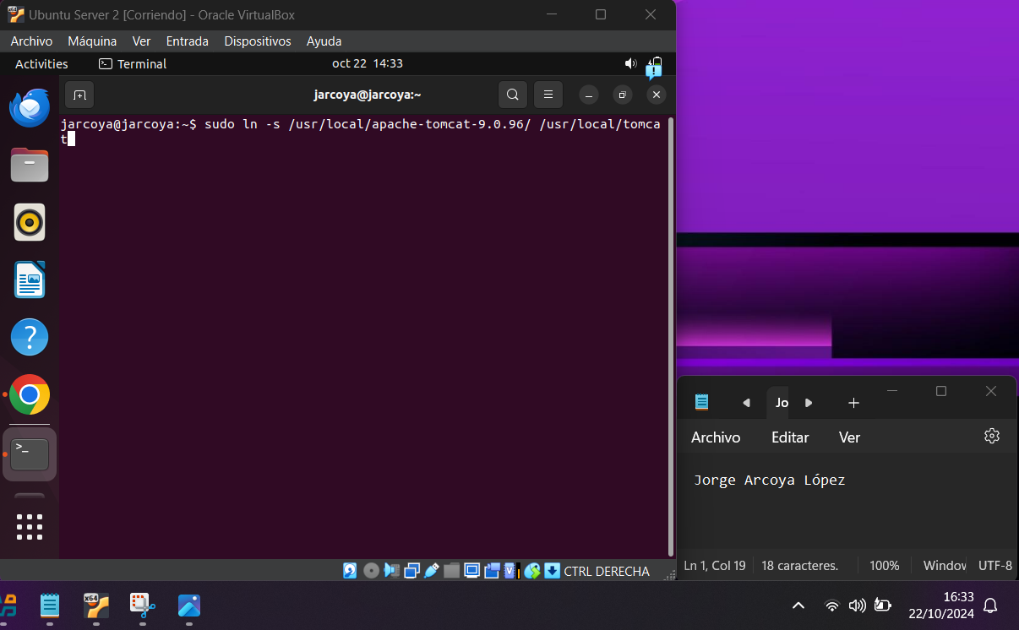To make updates more comfortable, you can create a link. To create it, use the command "sudo ln -s /usr/local/apache-tomcat-9.0.56/ /usr/local/tomcat" changing the file to the version you have. Image 16 shows how to enter the command.

Picture 17 Create a link

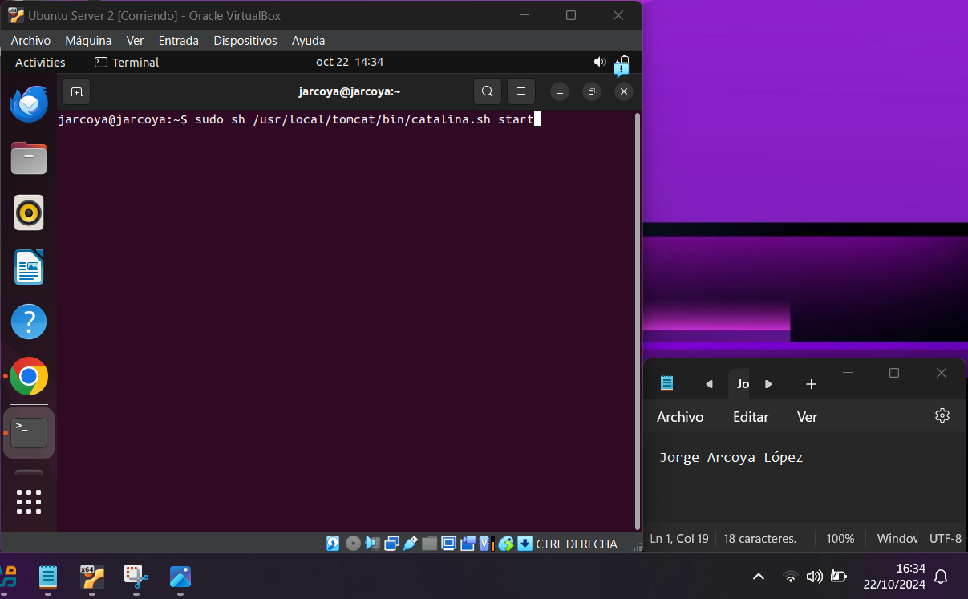Finally, in Tomcat, the management of the service is done through the included script called "catalina", to which we can give the parameters "start" and "stop" with which we would start or stop the service manually, to do this we have to execute the following command "sudo sh /usr/local/tomcat/bin/catalina.sh start", figure 17 shows how to put it.

Picture 18 Start the service

Tomcat Check

To check that Tomcat is installed and running, open a browser and enter the URL “localhost:8080”, Figure 18 shows how to do this.

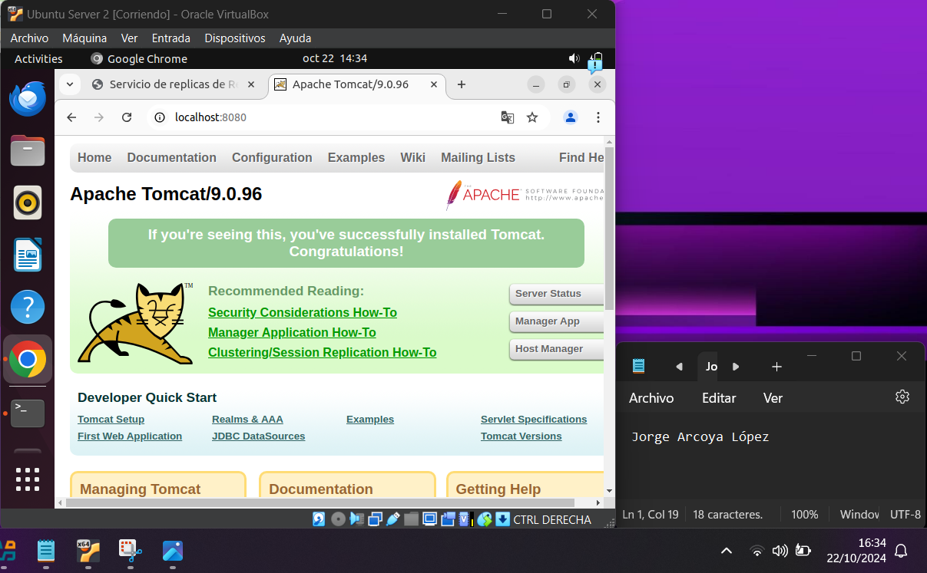If this does not work, check that the last step of starting Tomcat has been done using the command “sh /usr/local/tomcat/bin/catalina.sh start”, this command must be run each time the machine is rebooted to start Tomcat.

Picture 18 Tomcat Check

Bibliografía

Link to copy the tar gz of Tomcat: <https://ftp.rediris.es/mirror/apache/tomcat/tomcat-9>